**CAPSTONE-PROJECT-THE BATTLE OF NEIGHBOURHOOD**

by- Anshika singh

**INTRODUCTION**

When a new person moves from India to New York due to job change or any other reasons, some questions come in his mind regarding the Indian food/restaurants . e.g.

• Which areas have potential Indian restaurant market?

• What is best place in New York City for Indian Cuisine?

And the same problem arises when a person want to open a new Indian restaurant in the New York.

The person also wants to know which is the best Borough to open a new restaurant?

So, in this project we will try to find the solution of above mentioned questions and try to find out best places in New York for Indian Cuisine and also find out the best Borough to open a new Indian restaurant. Also, we will visualize the Indian restaurants in all major parts of New York City.

**DATA**

For resolving the above mentioned problems, we need the following data: Indian restaurants in each neighborhood of New York City ?

**Data Source: Foursquare API**

**Description:**

By using this API we will get all the venues in each neighborhood. We can filter these venues to get only Indian restaurants New York City data which contains list Boroughs, Neighborhoods along with their latitude and longitude ?

**Description:**

This data set contains the required information. And we will use this data set to explore various neighborhoods of New York City

**Methodology**

* For getting the answers of the problems ,we did the following steps:
* We imported the required libraries for python.
* Pandas and numpy for handling data.
* Request module for using foresquare API .
* Geopy to get co-ordinates of city of New York.
* Folium to visualize the results on a map.
* We filtered out all venues that are Indian restaurants
* We collected New york city data from <https://cocl.us/new_york_dataset>
* We use Foursquare Api to find all venues for each neighbourhood..
* We find rating ,tips and like count for each indian restaurant using Foursquare API.
* We used rating for each restaurant ,and then sort that data .
* We visualized the Ranking of neighbourhoods using folium library (python).

**Below screenshot shows the Neighbourhood for each Borough in New York city .**

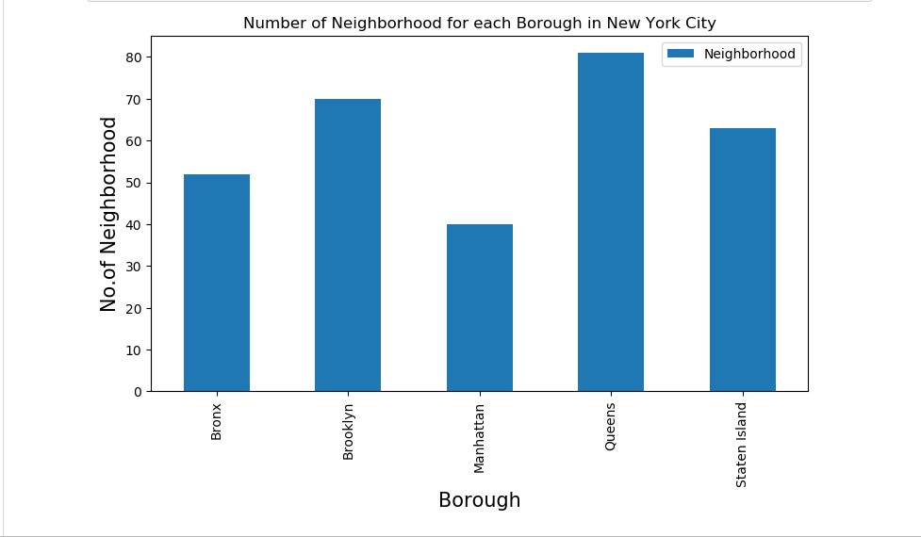

Below screenshot shows the number of Indian Restaurants for each Borough in New York city.

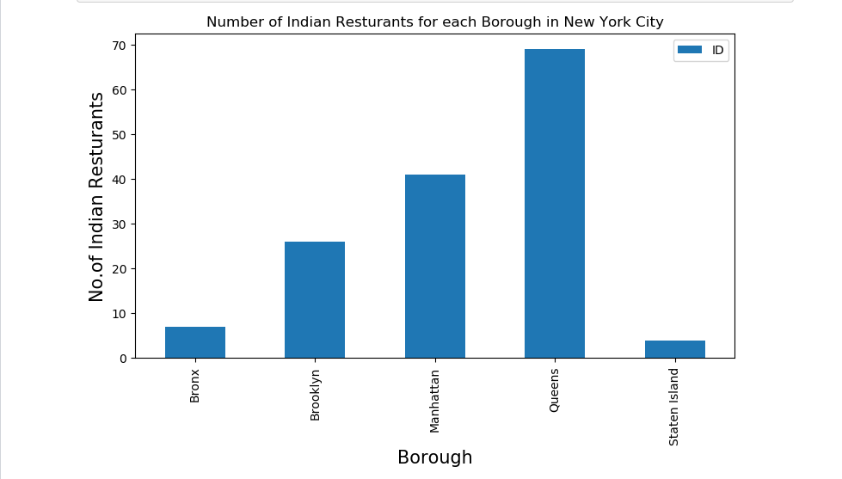

Below screenshot shows the number of Indian Restaurants for top 20 Neighbourhoods in New York city.

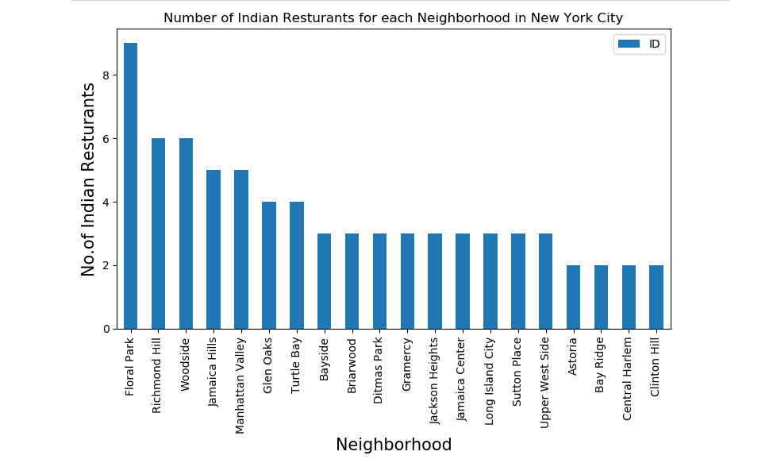

Below screenshot shows the average rating of Indian Restaurants for each Borough.

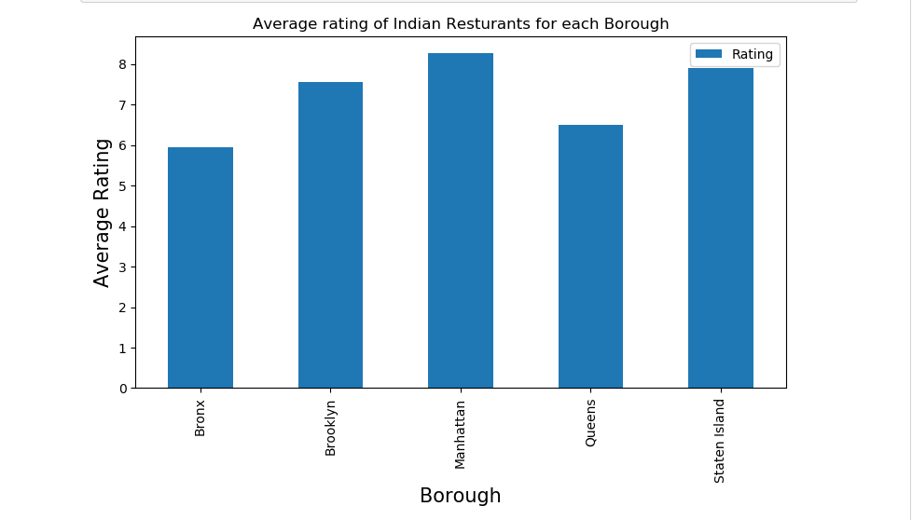

**RESULT**

Below screenshot shows the average rating of Indian Restaurants for each Borough.

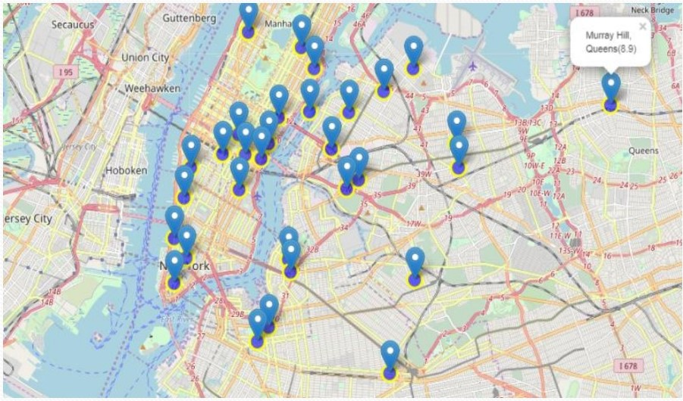

**CONCLUSION**

* Based on above results we find answers of all the problems mentioned in the introduction section.
* Some observations are as follow:-
* Blissville (Queens), Civic Center(Manhattan) are some of the best neighborhoods for Indian cuisine.
* Manhattan have potential Indian Restaurant Market.
* 'Queens' (Borough) have highest number of Indian restaurants.
* 'Flora Park' (Neighborhood) has highest number of Indian Restaurants.
* Manhattan is the best place to stay if you prefer Indian Cuisine because it has highest average rating of Indian Restaurants.
* 'Staten Island' and 'Bronx' both have minimum number of Indian Restaurants, so these both places are suitable for opening a new restaurant.